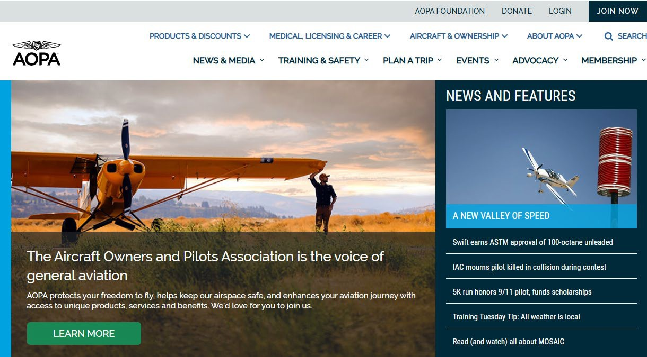
If you do not already have an account, you will need to sign up for an account by clicking JOIN NOW

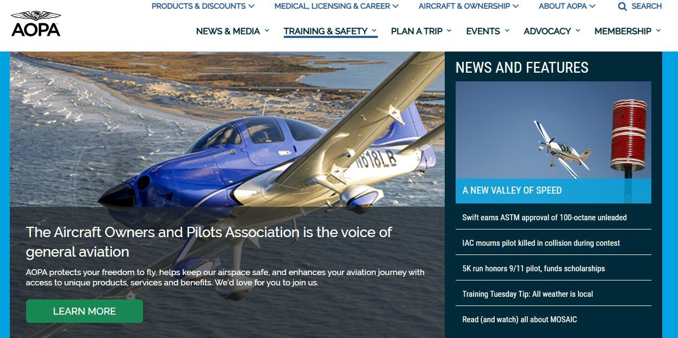
Once you have logged in, you can navigate to the training by going to Training & Safety

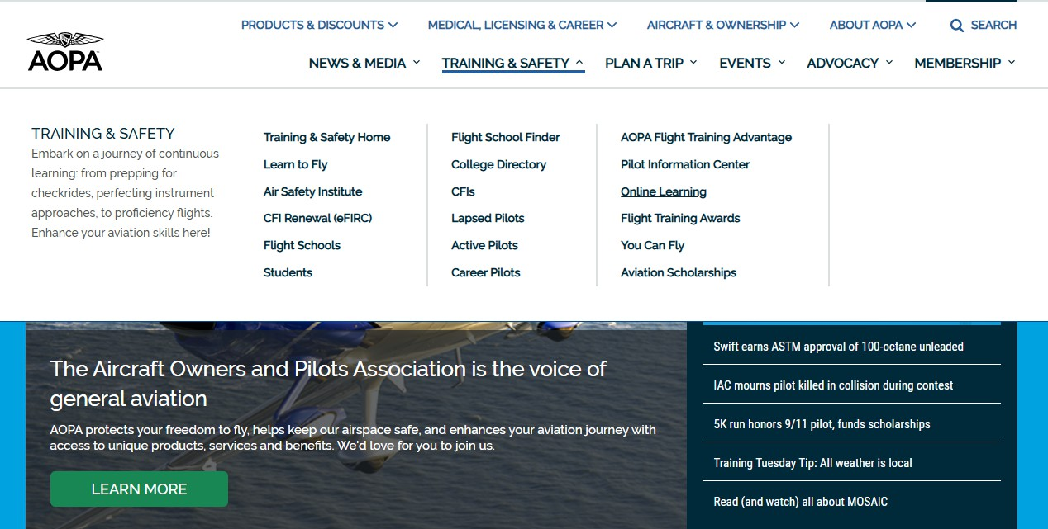
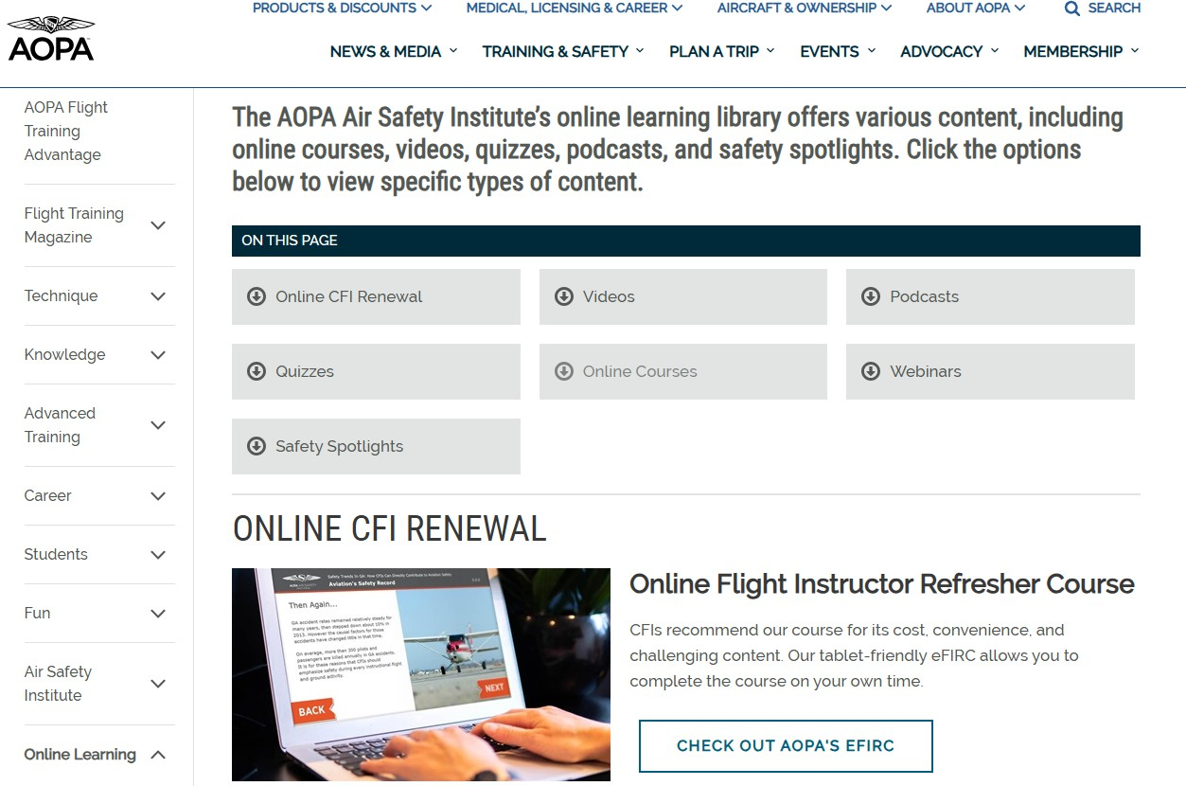
The link will bring you to the page where all their training materials are- next select Online Course, which will auto navigate you to the correct section

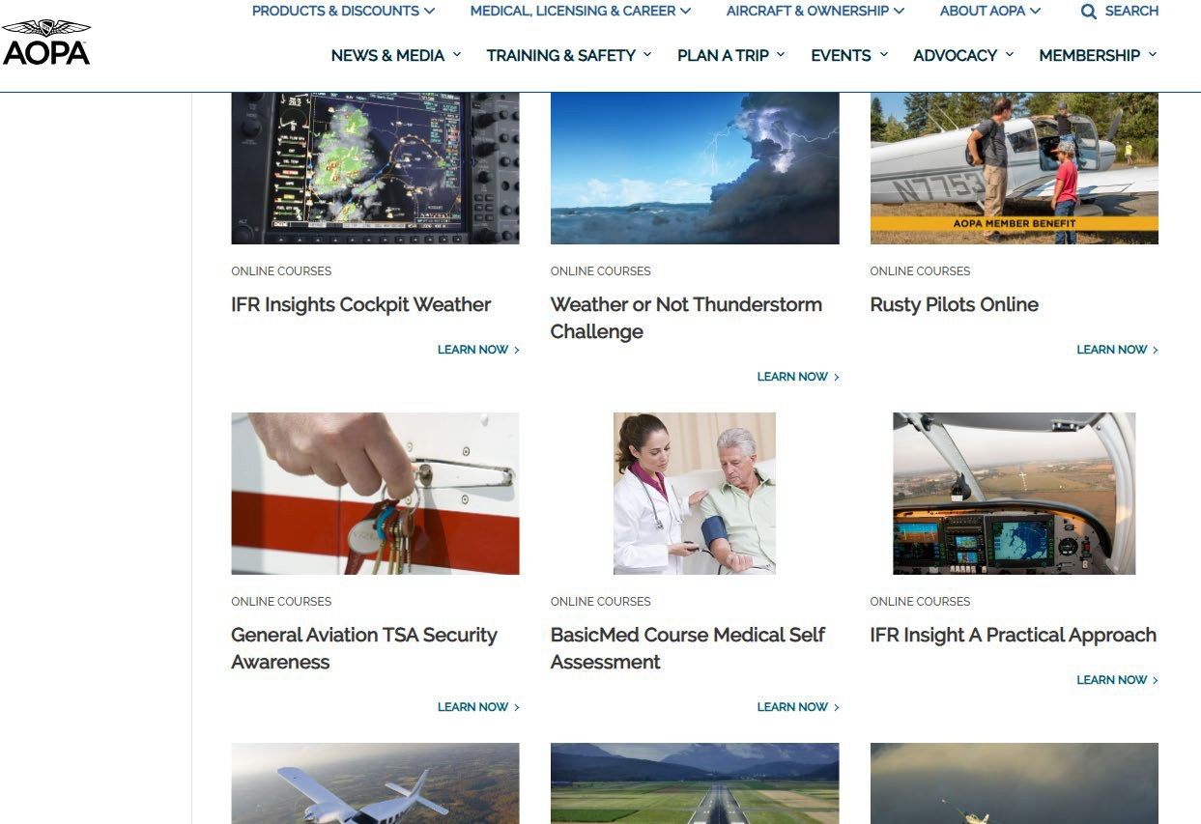

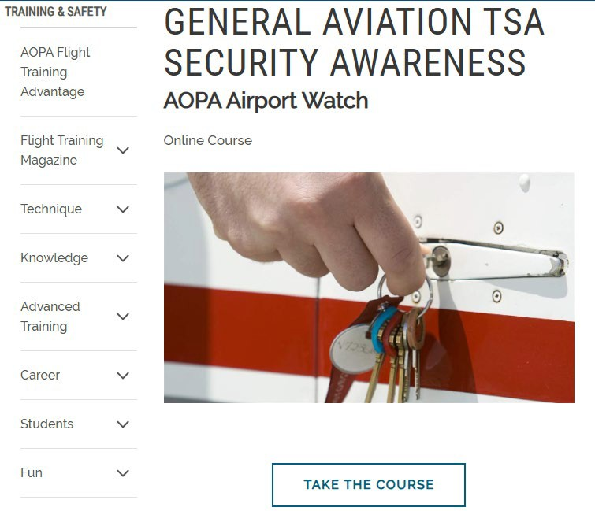
Once through the Intro, Pilot & Airplane and Passengers sections, you will come to the Track Selection.

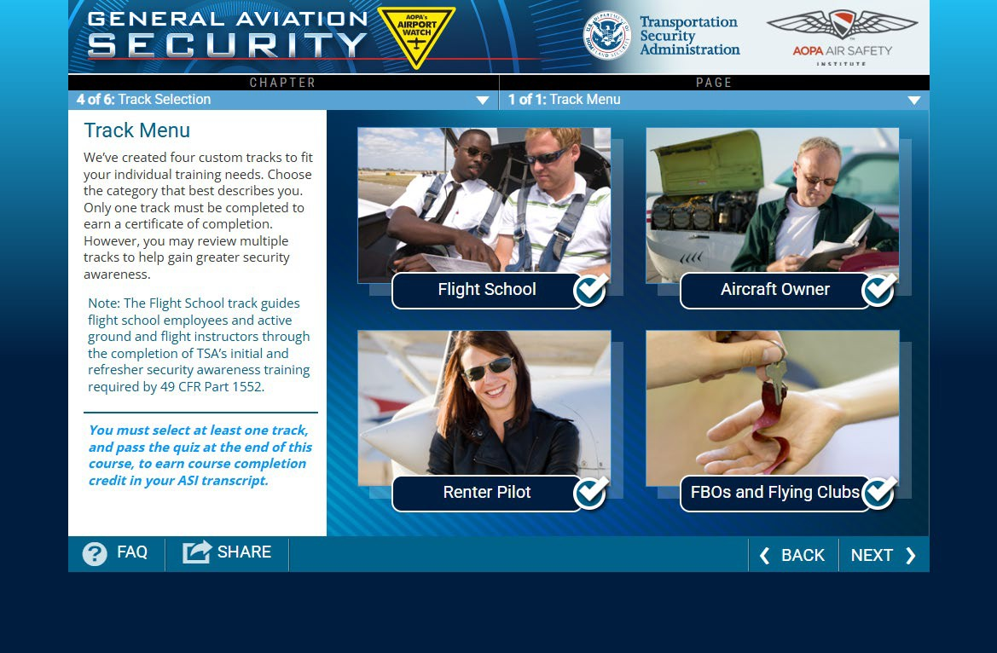
All School of Aviation faculty and staff shall complete both the ‘FBOs and Flying Clubs’ track and the ‘Flight School’ track

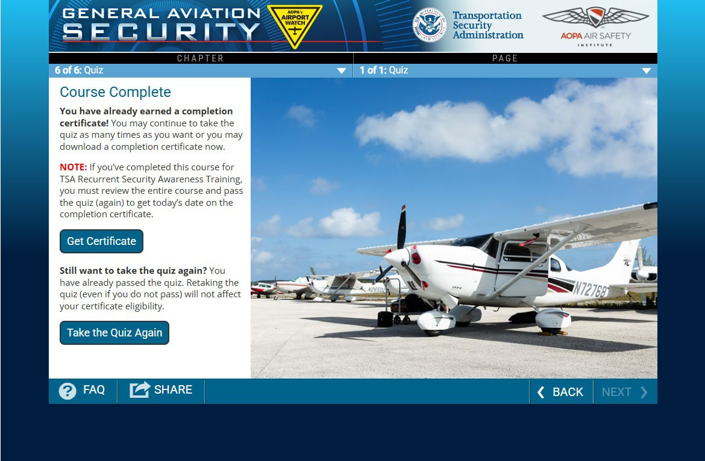
generate a certiﬁcate.

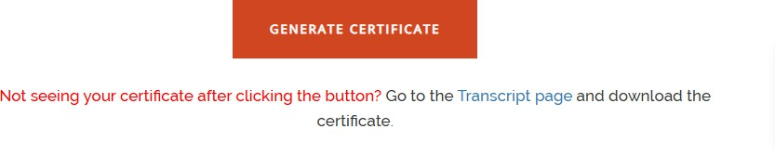
Click on Get Certiﬁcate, then on the following screen select Generate Certiﬁcate

Your certiﬁcate should generate in a separate tab.

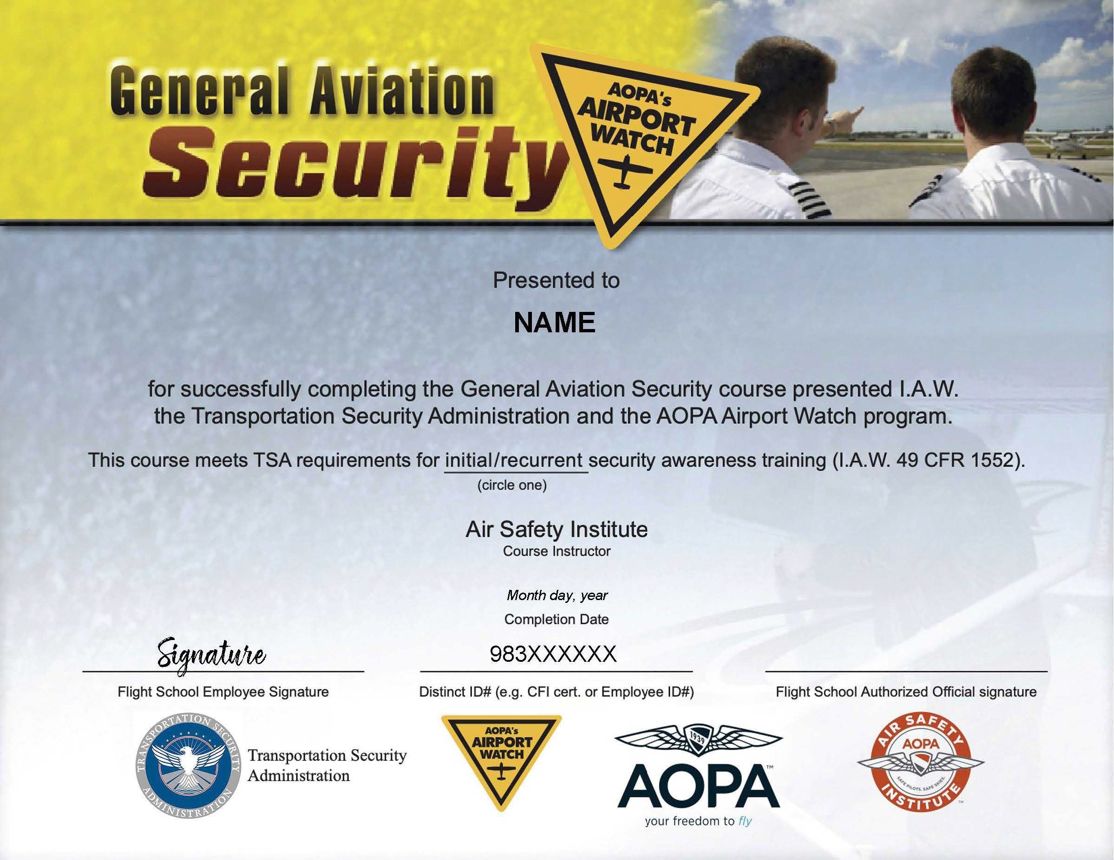
Save your certiﬁcate and either print or edit in pdf form to add your signature and your 983 number to the certiﬁcate.

Finally, Send the completed certiﬁcate to Peyton Yniguez through campus mail (Eastman
Campus) or scan and send it to peyton.yniguez@mga.edu.

