

School of Aviation

Safety Management System

Table of Contents
1- Introduction 3
2- Safety Policy 4
2.1 Safety Policy Statement 4
2.2 Safety Objectives 5
2.3 Organizational Structure and Responsibilities- Aviation Safety Personnel 5
2.4 Emergency Response and Preparedness 6
2.5 Emergency Call Tree 7
2.6 Compliance with Standards and Legal Requirements 7
3- Safety Risk Management 9
3.1 Hazard Identification 10
3.2 Anonymity and Non-Reprisal Policy 11
3.3 Risk Analysis and Assessment 11
3.4 Risk Control and Mitigation 14
3.5 Documentation and Records 15
4- Safety Assurance 17
4.1 Safety Committee 17
4.2 Inspections 17
4.3 Audits 17
4.4 Management of Change 18
5- Safety Promotion 19
5.1 Training 19
5.2 Communication 19
Appendix A: Definitions 20
Appendix B: Mandatory Incident Reports 22
Appendix C: Lessons Learned Sheet 23
Appendix D: Safety Hazard Reporting Form 25
Appendix E: Safety Inspection Checklists 26
Appendix F: Safety Culture Checklist 30
Appendix G: Safety Risk Hazard Analysis Worksheet 32
1- Introduction
This Safety Management System (SMS) Manual was developed for use by Middle Georgia State University’s School of Aviation (MGASOA) to promote and ensure safe operations within its four programs. This SMS was written, in part, to assist in MGASOA’s mission:
to educate and prepare students for technical and management careers in the aviation, aerospace, and related industries, who understand the industry and organizations they are part of, and the communities they serve.
The aviation and aerospace industries are ever-growing, creating a more challenging environment. It is part of MGASOA's mission to provide a standardized safety structure to produce a conducive learning and working environment. MGASOA's SMS Manual will provide faculty, staff, and students with systematic processes and methods to identify and analyze hazards and implement mitigations to reduce risk. MGASOA personnel can also use this SMS Manual for guidance regarding their responsibilities, authorities, and performance duties as they pertain to the Safety Culture of MGASOA. The application of this SMS will instill a healthy attitude toward safety for all faculty, staff, and students. The hope is that students can carry this safety culture with them into their careers.
MGASOA SMS Manual is developed and updated from the guidance of FAA Advisory Circulars 150/5200-37A and 120-92B, 14 CFR Part 5, FAA Orders 5200.11A, 8040.4B, 8000.369C, VS 8000.367C, and VS 8000.370C, and ICAO Safety Management Manual-Doc 9859.

2- Safety Policy
2.1- Safety Policy Statement
The Middle Georgia State University School of Aviation (MGASOA) is committed to operating in a safe and healthy environment that promotes a positive safety culture for all faculty, staff, and students. The implementation of the MGASOA Safety Management System (SMS) facilitates the practice of a high level of safety performance in all aviation activities. The continuous monitoring and improvement of SMS procedures will allow us to meet and exceed safety expectations. MGASOA continues to regard safety as a top priority by providing all necessary resources required to ensure the success of the SMS, as well as actively seeking input from all levels of MGASOA personnel and increasing safety communications.

Although all MGASOA faculty, staff, and students are part of cultivating a safety-conscious campus, we believe creating a positive safety culture begins with the Dean of the School of Aviation. The responsibility of enforcing and maintaining MGASOA’s SMS strategies and processes falls to the members of the Safety Committee, including the Dean, Associate Dean, Safety Manager, Air Traffic Control Manager, Aviation Maintenance and Structural Technology Department Chair, Director of Aircraft Maintenance, and the Chief Flight Instructor. The Safety Committee will develop and review safety objectives that will encourage a positive and proactive safety culture.

We are committed to increasing proactive methods of hazard identification. A major attribute of our proactive safety is a confidential hazard reporting system. Through the reporting system, MGASOA personnel can submit immediate identification of risk concerns or hazards. Reporters are given the option for anonymity in addition to the reassurance of a non-punitive policy for all reports regarding potential hazards, incidents, accidents, and other safety issues. Any reported activities involving intentional disregard for local, federal, or university policies and procedures may be subject to review and disciplinary action.

An effective SMS establishes standardized practices to mitigate hazards in the aviation environment. Our goal with the MGASOA SMS is to improve our safety culture and create a low to no-risk learning environment. Ultimately leading to an increase in safety information and interdepartmental data sharing, which will enable faculty, staff, and students to have a common understanding of safety at MGASOA.

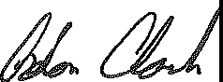
Adon Clark
Dean, School of Aviation

2.2- Safety Objectives
- Increase use of Safety/Hazard Reporting by 75% by 2028
- Increase student Safety Training to twice annually in 2024
- Increase completion of Online Safety Training for Students to 70% by 2025
- Update SOPs (Standard Operating Procedures) for Flight Operations Department with submission to the FAA by the beginning of the 2024-2025 school year.
- Develop SOPs for Maintenance and AMST (Aviation Maintenance and Structural Technology) Departments by the beginning of the 2024-2025 school year.

2.3- Organizational Structure and Responsibilities- Aviation Safety Personnel
Key Aviation Safety Personnel for MGASOA are the members of the Safety Committee. All members of the Safety Committee are held accountable for promoting, enforcing, and communicating the MGASOA SMS standards and procedures. The members and responsibilities of the Safety Committee are as follows:
Dean of the School of Aviation
- Providing the necessary resources to implement the SMS
- Developing long-term safety objectives, including the establishment of safety policies and practices
- Ensuring that all operations are conducted in the safest manner practicable.
Associate Dean of the School of Aviation
- Maintaining and reporting safety-related data as applicable to their position
- Conducting incident/accident reports
- Measuring performance and compliance of faculty, staff, and students with MGASOA’s goals and objectives
Safety Manager
- Updating, implementing, and managing the SMS
- Maintaining and reporting safety-related data
- Providing hazard and risk analysis
- Preparing and presenting audit reports and remedial actions
- Conducting necessary safety training or presentations
- Developing and delivering Safety Newsletters
- Actively promoting and monitoring safety in the School of Aviation
Aviation Maintenance and Structural Technology (AMST) Department Chair
- Maintaining and reporting safety-related data
- Developing and updating Standard Operating Procedures for faculty, staff, and students within their department
- Informing the Safety Manager of all safety-related meetings or events
- Conducting incident/accident reports
- Measuring performance and compliance of AMST faculty, staff, and students with MGASOA’s goals and objectives as well as regulatory requirement
Chief Flight Instructor
- Ensuring all flight operations personnel understand and comply with applicable regulatory requirements, standards, safety policies and procedures
- Identifying and developing resources to achieve safe flight operations
- Observing and controlling safety systems by monitoring and supervising Flight Instructors and Training Pilots
- Measuring performance compliance of Flight Instructors and Training Pilots with MGASOA’s goals, objectives as well as regulatory requirements
Director of Aviation Maintenance
- Ensuring all Maintenance Personnel understand applicable regulatory requirements and standards as well as MGASOA safety policies and procedures
- Developing and maintaining Standard Operating Procedures for Maintenance personnel
- Maintaining and reporting safety-related data
- Informing and updating Safety Manager about all safety-related meetings or events
- Identifying and developing resources to achieve safe maintenance operations
- Measuring Maintenance Personnel performance and compliance with MGASOA’s goals and objectives as well as regulatory requirements
Air Traffic Control Manager
- Ensuring all Air Traffic Personnel understand applicable regulatory requirements and standards, as well as MGASOA safety policies and procedures
- Maintaining and reporting safety-related data
- Informing and updating Safety Manager about all safety-related meetings or events
- Identifying and developing resources to achieve safe air traffic operations
- Measuring performance and compliance of Air Traffic Controllers and Air Traffic Management Students with MGASOA’s goals and objectives as well as regulatory requirements

2.4- Emergency Response and Preparedness
The MGASOA Safety Committee identifies the potential for accidents and incidents through proactive analysis programs. The Safety Committee will respond to accidents and/or incidents and is responsible for the MGASOA emergency response and planning.
Depending on the type and location of the emergency, one or more of the State, City, University, or School Emergency Plans and/or Standard Operating Procedures (SOPs) will be utilized. Emergency Plans and SOPs can be found online or in their designated departments.
To ensure that all MGASOA personnel are knowledgeable of their roles during an emergency, drills are conducted annually. In addition to emergency drills, all MGASOA faculty, staff, and students are given the necessary training through classes or presentations.
State of Georgia Emergency Management Information
- Georgia Emergency Operation Plan: https://gema.georgia.gov/what-we-do/planning
- Georgia Hazard Mitigation Strategy: https://gema.georgia.gov/state-hazard-mitigation-strategy
Heart of Georgia Altamaha Region
- Dodge County, Georgia Hazard Mitigation Plan: http://www.hogarc.org/wordpress/wp-content/uploads/2018/11/Dodge-HazMit.pdf
Middle Georgia State University Emergency Information
- Emergency Information: https://www.mga.edu/police/emergency-information.php
- Emergency Response Plan: https://www.mga.edu/police/emergency-response-plan.php

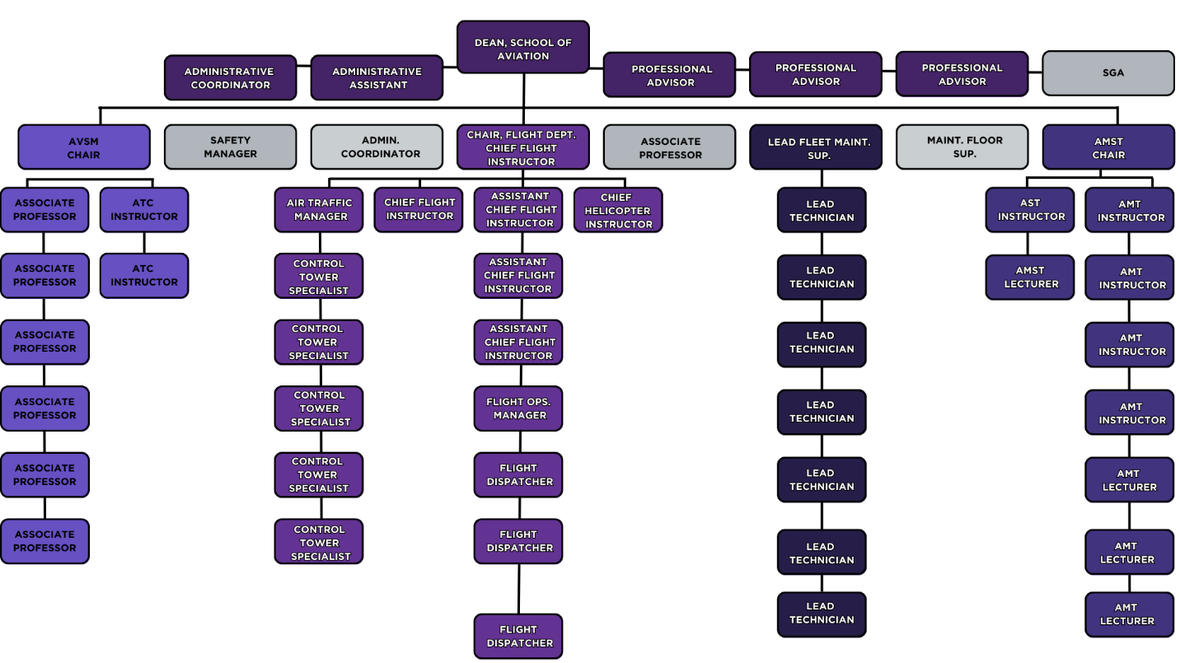
2.5- Emergency Call Tree

2.6- Compliance with Standards and Legal Requirements
All Middle Georgia State University faculty, staff, and students have the duty to comply with

- Middle Georgia State University policies and procedures
- Aircraft manufacturer operating procedures and limitations
- State and local government regulations

Although MGASOA acknowledges an acceptable level of risk, unnecessary risks are ill-advised. It is important to understand that a thriving and functional organization always has underlying risks. However, MGASOA will implement procedures (such as this SMS) in order to alleviate the potential for serious risk or incident.

In the interest of maintaining a low-risk environment, events of noncompliance with MGASOA policies will be assessed. This assessment will allow MGASOA Management to determine whether the deviation was intentional or unintentional. MGASOA Management strives for a clear distinction between honest mistakes and willful defiance. Following this determination, corrective action may be required. Corrective action can include counseling, training, discipline, grounding, or removal. In all situations, corrective action must be consistent and fair.

Maintaining a Just Culture at MGASOA is imperative to creating a healthy and safe environment. As such MGASOA policy agrees with the following statements
- Compliance with known procedures produces known outcomes
- Complacency affects the safety of operations
- Safety is everyone’s responsibility

MGASOA is committed to adhering to Federal, Local, University and School policies and procedures that ensure the growth and safety of the community.

3- Safety Risk Management
An effective Safety Risk Management (SRM) process will aid MGASOA in achieving a safe environment via a proactive safety culture. MGASOA developed this SRM process to enhance the Safety Committee's ability to identify, assess, analyze, and mitigate hazards.

Figure 1: 5 Step Process of Hazard Management
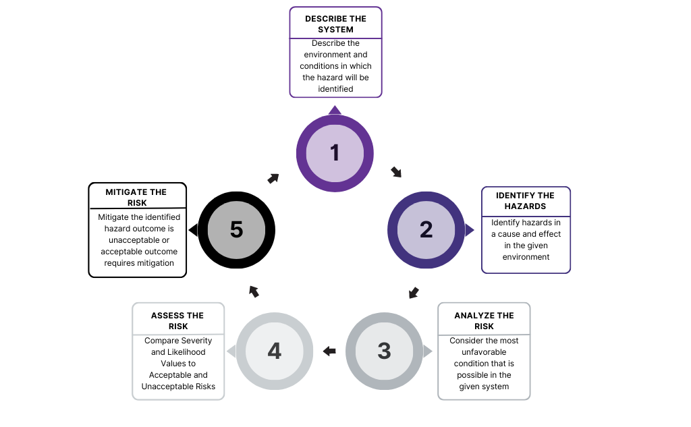
ANALYZE THE RISK
Consider the most unfavorable condition that is possible in the given system
ASSESS THE RISK
Compare Severity and Likelihood Values to Acceptable and Unacceptable Risks
MITIGATE THE RISK
Mitigate the identified hazard outcome if unacceptable or if acceptable, requires mitigation
IDENTIFY THE HAZARDS
Identify hazards in a cause and effect in the given environment
DESCRIBE THE SYSTEM
Describe the environment and conditions in which the hazard will be identified
1

4

2

3

5

The 5 Step SRM process should be used in any of the following conditions:
- Implementation of a new system
- Revision of a new system
- Development of new procedures
- Identification of ineffective mitigation strategies

MGASOA utilizes two models to identify systems and analyze risks. Both the SHELL Model and the 5M Model are often used in the aviation industry, usually during an accident or incident investigation. Although both models have similar systems and processes, the SHELL Model tends to be used for proactive analysis, while the 5M Model is used for reactive analysis.

Figure 2: SHELL Model

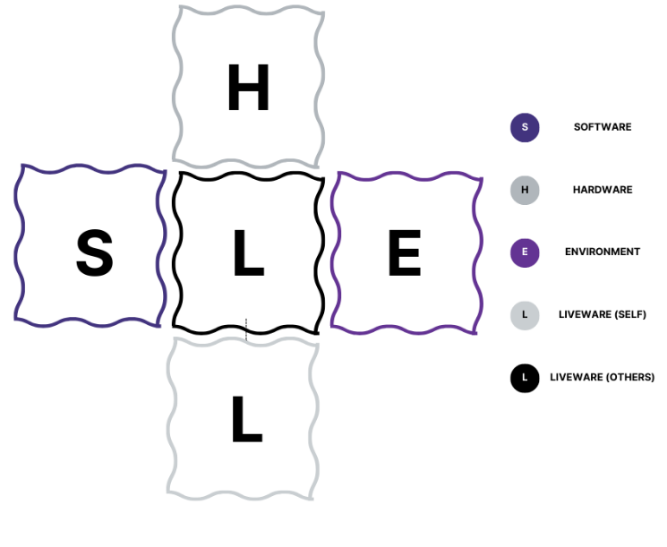

Figure 3: 5M Model

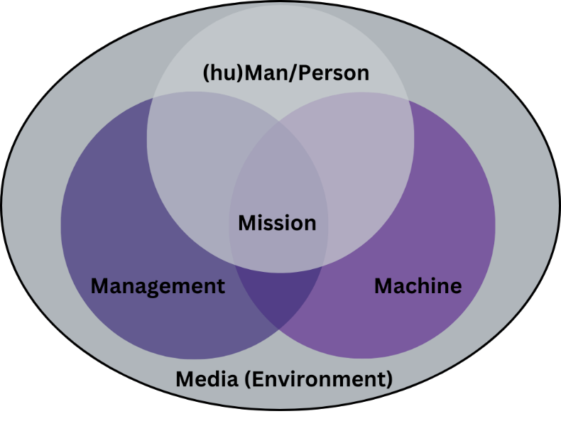

MGASOA recognizes several events as Triggering Events. If a Triggering Event has occurred, a member of the Safety Committee should immediately begin the 5 Step SRM process. The following are events that MGASOA qualifies as a Triggering Event:
- Construction
- New or modified SOPs
- Safety Reports
- Special Events
- Safety Assurance Evaluation

3.1- Hazard Identification
Due to the dynamic environment of MGASOA reactive and proactive procedures for identifying hazards are in place. These procedures include safety reporting, departmental meetings, Safety Committee meetings, general safety meetings, audits, inspections and investigations.
MGASOA has multiple avenues available to faculty, staff, and students for reporting safety concerns, hazards, occurrences, incidents, or accidents. These include Safety Concern reporting online via a QR Code, suggestion boxes, Lessons Learned reporting, and Incident Reporting.
The proactive avenues for safety reporting are the suggestion boxes and the online safety concern form. Access to both reporting systems are located in various locations throughout the campus. Any safety concerns or suggestions are encouraged to be submitted via the suggestion box or online form. The submissions will be collected and analyzed by the Safety Manager. The reactive avenues for safety reporting are Lessons Learned reports and Incident Reports. These forms are filled out and submitted after an event. Both are collected and analyzed by the Chief Flight Instructor or appropriate Department Chair and submitted to the Safety Manager. Faculty, staff, and students are all responsible for filling out and submitting these forms when/if an incident occurs. To assist in identifying an incident, Appendix B or MGA Department SOPs should be referenced.
Any MGASOA Personnel must report any observed current or potential hazard. A current or potential hazard can be where any event, practice, procedure, or process is observed which is either:
- a recognized safety concern
- considered unusual from an operational or procedural standpoint
- considered deficient from a safety standpoint
Any concern that would be of interest to MGASOA students, faculty, or staff should be reported. Suggestions to further the safety culture of MGASOA are always encouraged. Ultimately, any avenue, whether written or verbal, of reporting to a member of the Safety Committee is acceptable.

3.2- Anonymity and Non-Reprisal Policy
The objective of MGASOA's safety reporting system is to identify and eliminate any potential hazards, and to prevent any unsafe occurrences. The purpose of hazard identification is not to place blame on any individual or group. All reporters are encouraged to submit their names and contact information; however, they always have the option to remain anonymous. It is the policy of MGASOA to protect the identities of all reporters to the extent permissible by law. Reporters are treated without bias or punitive action from MGASOA faculty and staff. Any known repeated disregard for established policies, practices, or regulations will be viewed through the Just Culture attitude.

3.3- Risk Analysis and Assessment
MGASOA Safety Committee members are responsible for risk analysis and assessment. Risk analysis and risk assessment should be performed by:
1) the Safety Committee Member with the most understanding of the described system, or
2) the Safety Committee as a whole, if deemed necessary
The Severity Scale, Probability Scale, Predictive Risk Matrix, and Acceptable/Unacceptable Risk Matrix were developed to standardize assessments. The scales and matrices help to consider the most consequential outcome while maintaining plausibility. When possible, it is best to use qualitative and quantitative methods in analysis and assessment.

Table 1: Severity Scale and Definitions
Severity
Level | Meaning | Value
Minimal | - No aircraft damage  - No injury  - No effect to airport operations  - Minor damage to equipment or facility not requiring it to be taken out of service  - No impact on school reputation  - Non-reportable environmental impact | A
Minor | - Aircraft damage requires less than a day to repair and immediate return to service  - Physical discomfort or injury nor requiring medical treatment  - Slight effect on safety/achievement of airport operations  - Moderate impact of school reputation with surrounding community  - Environmental impact reportable without a fine | B
Major | - Aircraft damage that is repairable but requires more than 24 hours  - Operating in uncertain but ultimately safe conditions  - Physical distress resulting in injuries requiring medical treatment  - Moderate damage to equipment or facilities  - Significant effect on safety/achievement of airport operations  - Significant impact on school reputation at a regional level  - Environmental impact consisting of physical damage and/or a fine | C
Hazardous | - Major aircraft damage, resulting in extended time of repairs  - Operating aircraft in unairworthy or unsafe conditions  - Severe injury resulting in hospitalization  - Significant damage/disruption of airport operations and safety  - Significant impact of school reputation at regional level causing negative financial or operational impacts  - Considerable damage to people/facilities/equipment with significant fine and cost, due to environmental impact | D
Catastrophic | - Irreparable loss/destruction of an aircraft  - Fatality or permanent disability  - Total loss of airport operations  - Irreparable loss of equipment or facilities  - Severe impact of school reputation at national level  - Loss of people, facilities, or equipment and highest fine and cost due to environmental impact | E

Table 2: Probability Scale and Definitions
Likelihood
Level | Meaning | Value
Improbable | - Unlikely to occur, almost inconceivable possibility  - Occurrence once every 10+ years | 1
Remote | - Not likely to occur, but still possible  - Not known to have occurred.  - Occurrence once every 5 years. | 2
Seldom | - Will occur often if not changed  - Possibility of occurrence within a year | 3
Probable | - Will occur if events follow normal patterns of process/procedure  - Yearly occurrence | 4
Frequent | - Will occur continuously unless action is taken  - Will occur many times within 30 days | 5

Table 3: Predictive Risk Matrix
Risk Likelihood | Risk Severity
Risk Likelihood | Minimal (A) | Minor (B) | Major (C) | Hazardous (D) | Catastrophic (E)
Improbable (1) | A1 | B1 | C1 | D1 | E1
Remote (2) | A2 | B2 | C2 | D2 | E2
Seldom (3) | A3 | B3 | C3 | D3 | E3
Probable (4) | A4 | B4 | C4 | D4 | E4
Frequent (5) | A5 | B5 | C5 | D5 | E5

Table 4: Acceptable and Unacceptable Levels of Risk
Low Risk:  A1, A2, A3, B1 | Acceptable without further action
Minor Risk:  B2, B3, A4 | May be acceptable with continuous monitoring. Improvement is possible
Moderate Risk:  C1, C2, C3, D1, E1 | May be acceptable with review, requires continuous tracking and probable action. Improvement is needed,
Serious Risk:  A5, B4, B5, C4, D2, D3, E2 | Unacceptable, requires timely investigation and corrective action. Current controls, policies or procedures are inadequate
High Risk:  C5, D4, D5, E3, E4, E5 | Unacceptable under existing circumstances, requires immediate investigation and corrective action.

3.4- Risk Control and Mitigation
MGASOA uses five levels of risk: Low (green), Minor (blue), Moderate (yellow), Serious (orange), and High (red). Each risk is then categorized as Acceptable, Acceptable with Mitigation, or Unacceptable. Generally, a Low Risk is defined as Acceptable, while Serious Risk and High Risk are Unacceptable Risks. Minor or Moderate risks are usually on either end of the scale but can be Acceptable with Mitigation.
Acceptable with Mitigation controls are straightforward and can be done in a reasonable amount of time. These actions can range from physically altering the environment to simply communicating with MGASOA personnel.
When presented with an Unacceptable Risk immediate action should be taken. Unacceptable Risk Control generally requires alterations to operations, although, depending on the severity of the risk, completely halting operations may be necessary.
Mitigations may be considered for Acceptable Risks if it is determined a no risk outcome is possible.
At any level of risk, procedures should be placed to reduce the risk. Some of the more common mitigation practices are:
- Avoiding risk by stopping or suspending the activity
- Reducing the frequency of the activity
- Creating redundancy to lessen the severity of the risk
- Raising awareness
- Providing training
- Developing or modifying procedures
- Installing safety equipment
- Increasing supervision
- Improving infrastructure
Depending on the mitigation, either a single Safety Committee member will implement action, or a Safety Committee Meeting will be necessary to decide on appropriate action. If the Committee does not need to meet, the Committee Member responsible for the mitigation action should update the Committee during the next meeting.
An Unacceptable Risk will necessitate a Safey Committee Meeting. The Committee will then discuss and implement the mitigation and ensure all discussion and action is documented and recorded.
After all mitigation actions, follow-up inspections will be conducted to ensure the mitigations are effective and documentation is updated.

Figure 4: Safety Risk Management Process
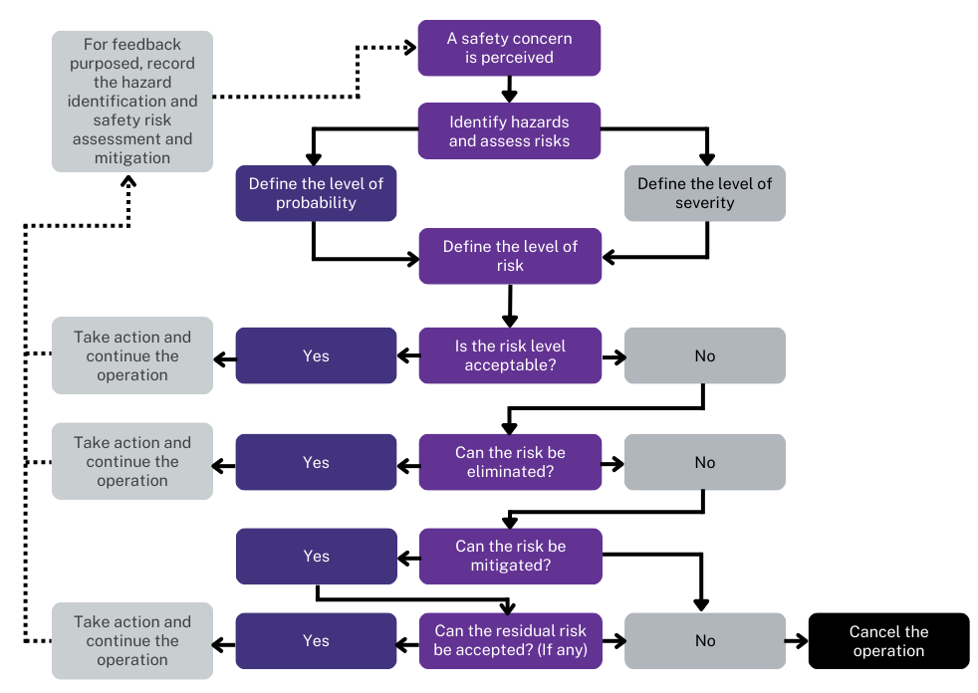

3.5 Documentation and Records
MGASOA Safety Committee is responsible for all Safety documentation and records. Committee members should retain documents of any reporting, meetings, or other pertinent information within their own departments. Safety Committee members are also responsible for sending a copy of any safety-related documentation or records to the Safety Manager.
The Safety Manager is responsible for retaining all MGASOA safety documentation and records. The Safety Manager is also responsible for all documentation for Safety Committee Meetings, any documentation related to SRM or SMS, annual reports, safety newsletters, bulletins, or any other safety-related information. When an SOP is updated, the Safety Manager will replace the old SOP and retain the newest version.
Records retention policies will follow that of Middle Georgia State University (MGA) and the University System of Georgia (USG). Any documentation or records not found in University Retention policies will be kept for at least five (5) years unless otherwise determined. Documents and records must be securely kept in paper or electronic form.

Retention policies
- MGA Retention Policy: https://policies.mga.edu/policy-manual/section-10-records/10-3-records-management/10-3-3-records-retention.php
- USG Retention Policy: https://www.usg.edu/policymanual/section6/C2717/

4- Safety Assurance
4.1- Safety Committee
The Safety Committee meets bi-annually and as necessary. The Safety Committee Meeting should cover any safety concerns, recommendations, or results of safety action. The Safety Manager operates as Chair of the committee, establishing agendas, taking minutes, and recording action items for the meetings. The Safety Manager is primarily responsible for Safety Performance monitoring, although all Safety Committee members should be monitoring safety performance within their own departments. Safety Committee members are encouraged to bring to attention any issues they deem appropriate. Any incidents or hazards on the flight line, in hangars, or maintenance shops should be addressed. Using the committee meetings to discuss safety concerns allows for interdepartmental communication and inclusive feedback on all MGASOA safety concerns. Bi-annual meetings allow for:
- a review of SMS policies and procedures
- an evaluation of MGASOA’s existing operations
- an analysis of active changes
- discussion of anticipated changes
- preparation for future safety management
When a Safety Committee member has a concern, they feel is urgent, they will promptly bring this concern to the attention of the Safety Committee. The committee will decide the severity of the concern, what action is needed, and if communication with other MGA Management is necessary.

4.2 Inspections
The Safety Manager is responsible for internal inspections of each department. Periodic inspections should be performed to verify the continuous upkeep of daily operational standards and to monitor safety performance.
Inspections should be conducted with the intent of mitigating safety issues; meaning potential safety hazards and preventative/corrective actions are expected to be needed. All preventative/corrective actions will be non-punitive except in the case of gross negligence. Inspection findings, results, and preventative/corrective actions will be reviewed during the next Safety Committee meeting. In the case of an identified urgent safety concern, the issue will be addressed immediately with appropriate members of the Safety Committee. Findings, discussions, and results will be recorded and reviewed during the next Safety Committee meeting.

4.3 Audits
Internal safety audits, performed annually by the Safety Manager, will ensure the compliance of all departments with FAA, MGA, and MGASOA standards. The Safety Manager will maintain records of audit findings, including compliance, non-compliance, corrective actions, and follow-up inspections.
Internal Audits should include:
- Physical inspections of work areas, flight line, and maintenance shops
- Personnel certifications and licenses
- Operator’s and maintenance manuals
- Department SOPs
- Records and records-keeping procedures
- Safety culture in each department
- Parts and materials handling
- Facilities and equipment
Yearly audits will comprise a review and analysis of MGASOA inspections and a Safety Culture inspection of each department. Audit results, including SMS Safety Objectives progress, will be distributed to Safety Committee members, and presented during the next Safety Committee meeting.

4.4 Management of Change
MGASOA strives to remain up to date with any changes within the aviation environment. All applicable regulatory updates for Air Traffic Control, Pilots, Maintenance, Airport Safety, Aircraft Procedures, or other facets MGASOA is involved in must be complied with.
Any major or minor change affecting the operations of MGASOA will be analyzed and implemented if necessary. Significant changes will require an evaluation by the Safety Committee to eliminate or control all potential hazards before implementation.
The application of SRM procedures for proposed changes varies depending on whether the proposal is internal or external. Internal proposals will require a complete SRM application and approval from the Safety Committee. An external proposal, e.g., an Advisory Circular, will be implemented as soon as practicable, concurrent with hazard identification and risk analysis. Prior to its implementation, a complete understanding of a new procedure must be confirmed by all appropriate personnel. Immediately following implementation, all related manuals must be updated with the most current and accurate policies and procedures.

5- Safety Promotion
5.1 Training
All faculty and staff are expected to understand their part in the Safety Culture at MGASOA. All faculty and staff should have initial and yearly recurrent training to ensure the following:
- An understanding of safety policies and procedures
- An understanding of their role in implementing the SMS
- The promotion of safety in MGASOA- including but not limited to classrooms, ramp or flight line, maintenance hangars/shops
- The use of hazard and safety reporting
Initial and Recurrent training of Maintenance and Flight personnel should be monitored and documented by the Department Chair. Departmental training requirements should be in their SOPs.
Periodic training for faculty, staff, and students may be necessary when implementing a change in procedures, policies, or the SMS.
MGASOA students are encouraged to educate themselves on the policies and procedures of this SMS and appropriate SOPs. Students have semesterly training through their courses and a semi-annual Safety Briefing led by the Safety Manager. MGASOA students are expected to practice safety in classrooms, on the flight line and ramps, and in all hangars and maintenance shops. Students should understand proper procedure in and around aircraft and how to appropriately report any hazards, incidents, or accidents.

5.2 Communication
To ensure a thriving Safety Culture at MGASOA, the communication of safety information must always be at the forefront of the SMS program. Providing feedback and updates to those with safety concerns is crucial in promoting a healthy environment of feeling safe, seen, and heard. The active exchange of safety concerns and solutions by faculty, staff, and students remains a top priority.
The communicated safety information will range from “nice-to-know” information to SMS objectives and procedures. All safety information should be readily available for all personnel to review. The annual audit and SMS performance evaluation will be published by the Safety Manager either electronically or in hard copy (or both). All other safety-related data will be communicated to MGASOA personnel via a Safety Newsletter, in Safety Meetings, or posted on a bulletin. All safety information will be shared monthly, or more frequently if necessary.

Appendix A: Definitions
Acceptable with Mitigation Risk: any hazard categorized as acceptable with mitigation will require additional oversight to ensure that appropriate measures or restrictions are being taken to minimize the associated risk and be a catalyst for successful outcomes.
Acceptable Risk: The likelihood of a potentially hazardous event has been reduced to the point where the risk is allowed.
Accident: An occurrence associated with the operation of an aircraft that takes place between the time any person boards the aircraft with the intention of flight and all such persons have disembarked, and in which any person suffers death or serious injury, or in which the aircraft receives substantial damage.
Corrective Action: action to eliminate (remove) or mitigate (lessen) the cause or reduce the effects of a detected nonconformity or other undesirable (unwanted) situation.
Documentation: information or meaningful data and its supporting medium (e.g., paper, electronic, etc.). In this context, documentation is different from records because documentation is the written description of policies, processes, procedures, objectives, requirements, authorities, responsibilities, or work instructions; whereas Records are the evidence of results achieved or activities performed.
Event: a thing that happens, especially one of importance, a safety-related occurrence that endangers or, if not corrected or addressed is likely to endanger an aircraft, its occupants or any other person.
Hazard: A condition that has the potential to cause or contribute to an aircraft accident.
Incident: An occurrence other than an accident, associated with the operation of an aircraft,
which affects or could affect the safety of operations (49 CFR 830.2, Definitions).
Just Culture: The organization should engage in identification of systemic errors, implement preventative corrective action, and exhibit intolerance of undesirable behaviors such as recklessness or willful disregard for established procedures.
Likelihood: the estimated probability or frequency, in quantitative or qualitative terms, of an occurrence related to the hazard.
Occurrence: an accident, incident or event. The frequency of an event happening
Preventive Action: preemptive action to eliminate or mitigate the potential cause or reduce the future effects of an identified or anticipated nonconformity or other undesirable situation.
Procedure: a specified way to carry out an activity or a process.
Process: a set of interrelated or interacting activities that transform inputs into outputs.
Records: evidence of results achieved or activities performed.
Risk: The combined likelihood and severity of an event or hazard.
Safety: The state in which risks associated with, related to, or in support of the operation of aircraft has been reduced to an acceptable level.
Safety culture: the product of individual and group values, attitudes, competencies, and patterns of behavior that determine the commitment to, and the style and proficiency of, the organization’s management of safety. Organizations with a positive safety culture are characterized by communications founded on mutual trust, by shared perceptions of the importance of safety and by confidence in the efficacy of preventive measures.
Safety Management System (SMS): the formal, top-down business-like approach to managing safety risk. It includes systematic procedures, practices, and policies for the management of safety (as described in this document it includes safety risk management, safety policy, safety assurance, and safety promotion).
Safety Objective: a goal or desirable outcome related to safety. Generally based on the organization’s safety policy and specified for relevant functions and levels in the organization. Safety objectives are typically measurable.
Safety risk: The predicted probability and severity of the consequences or outcomes of a hazard.
Severity: the degree of loss or harm resulting from a hazard.
System: an integrated set of constituent elements that are combined in an operational or support environment to accomplish a defined objective. These elements include people, hardware, software, firmware, information, procedures, facilities, services, and other support facets.
Unacceptable Risk: any hazard categorized as unacceptable will necessitate that the associated process will cease operations immediately until appropriate mitigating measures have been taken to change the level of risk down to acceptable levels.

Appendix B: Mandatory Incident Reports
- If evasive action was taken due to loss of aircraft separation and/or possible collision
- Any instance of inadequate terrain clearance
- Pilot’s loss of situational awareness resulting in his/her loss of position for more than 30 minutes
- Failure of navigation or communication systems
- Electrical failure resulting in a precautionary landing
- Any physical damage to the aircraft, propeller, university property, or people
- Any unintentional exit from a paved surface while landing, taking off, or taxiing
- Critically low fuel quantity or landing with less than the prescribed reserve fuel load
- Any airframe icing encounter
- Severe turbulence
- Any evacuation of an aircraft for emergency purposes
- Engine failure or partial power loss
- Any ditching or controlled landing that is not on an airport runway
- Any intentional or unintentional violation of MGA’s Standard Operating Procedures
- Any runway incursion
- Landing on the wrong runway or at the wrong airport
- Any departure or excursion from the runway
- Weather related injury or damage
- Significant fuel leak
- Takeoff with a significant weight and balance error
- Injury to any person while in or outside the aircraft
- Lighting strike or bird strike
- Damage to aircraft by ground equipment
- Damage to non-university property
- Fire, explosion, smoke, or toxic fumes in or on the aircraft

NTSB Reportable Incidents (immediate notification required)
- Flight control system malfunction or failure
- Inability of any required flight crewmember to perform normal flight duties as a result of injury or illness
- In-flight fire
- Failure of structural components of a turbine engine excluding compressor and turbine blades and vanes
- Damage to property, other than aircraft exceeding $25,000 for repair
- Aircraft collide in flight

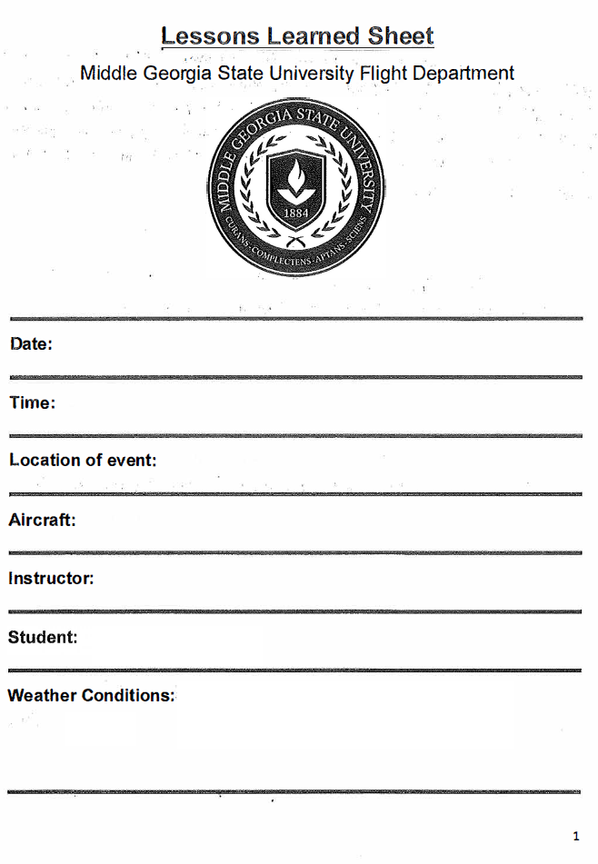
Appendix C: Lessons Learned Form
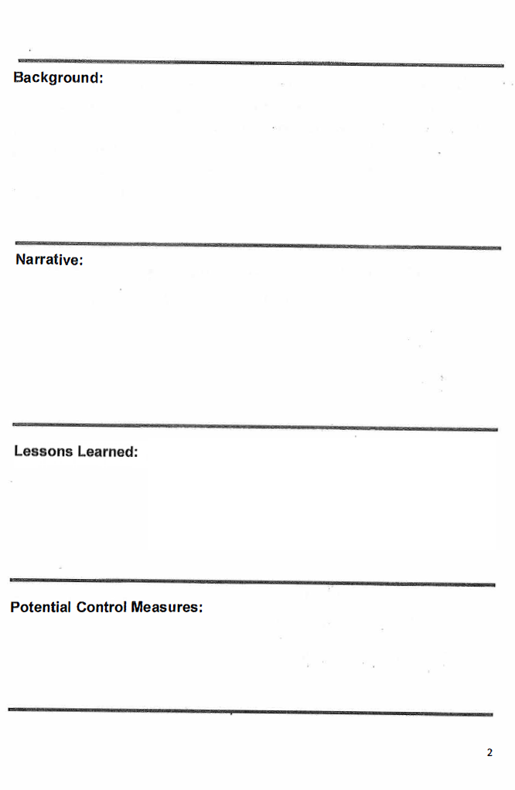
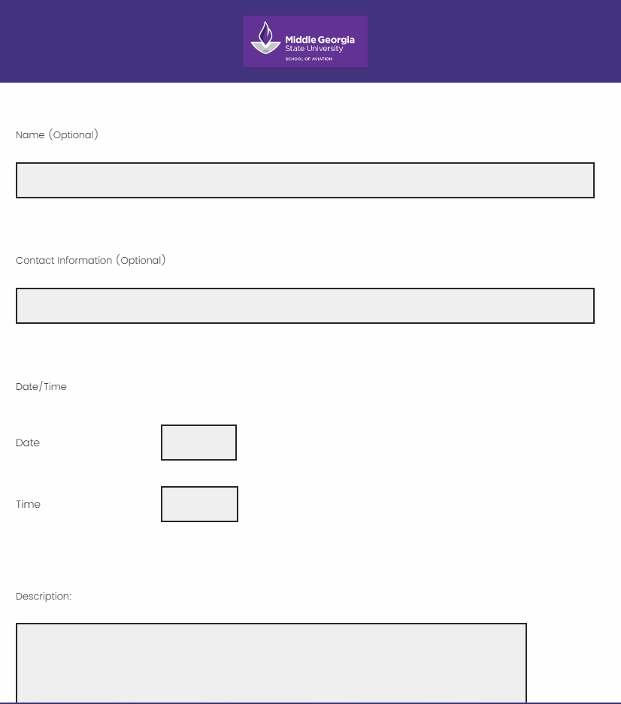
Appendix D: Safety Concern Report
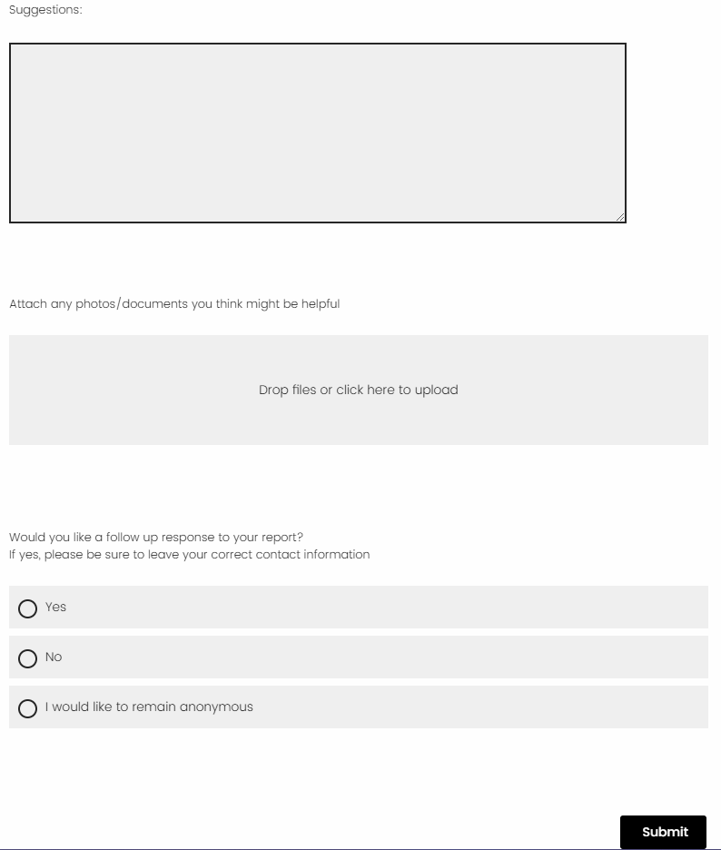
Appendix E: Inspection Checklists
Middle Georgia State University School of Aviation
Flight Operations
Inspection Checklist
General | Y | N | Comments
Is the flightline/ramp free of FOD?
Are all ramp lights operational during night operations?
Are trash cans being emptied on a regular basis?
Are all hangar doors functional?
Are taxi lines/lanes clean and visible?
Are spill kits readily accessible?
Are personnel wearing the proper attire/necessary PPE?
Fueling Operations
Are fuel truck drivers obeying 5 MPH speed limit?
Is fuel truck properly grounding when fueling?
Are the fuel trucks parked in their proper parking spots?
Are fuel trucks compliant with NFPA 407?
Are fuel sample containments being emptied properly?
Aircraft Operations
Are Aircraft handlers obeying the 5 mph speed limit?
During towing operations is the aircraft properly secured?
Are aircraft being properly secured after flight/tow?
Is all trash being removed from aircraft during post flight?
Do all aircraft have the proper fire extinguishers available?
Ramp Operations
Are personnel practicing situational awareness while walking/driving on the ramp?
Are personnel properly displaying ID while on the ramp?
Are ALL fire extinguishers mounted, marked, and covered properly?
Checklists/Manuals/Records
Is the latest version of SOPs readily available for all personnel?
Are fuel/ fuel truck inspections being documented regularly and properly?
Is personnel training being documented properly?

Other Comments: ________________________________________________________________________________________________________________________________________________________________________________________________________________________________________________

Name: ____________________ Signature:___________________ Date:__________

Middle Georgia State University School of Aviation
Aircraft Maintenance and Structural Technology
Maintenance
Inspection Checklist
General | Y | N | Comments
Is the hangar clean, well-organized and walkways clear of any obstructions?

Are aircraft placed in hangars in an orderly fashion?

Are trash cans being emptied on a regular basis?
Are all hangar doors functional?
Are all aircraft parts being properly labeled?
Are all tools put away when not in use?
Is adequate lighting provided in all work areas?
First Aid and PPE
Are First Aid kits in weatherproof box and items individually wrapped?
Is the First Aid Kit checked weekly?

Is PPE being used when required?

Is PPE being provided when necessary?
Are eye wash station available and serviceable?
Hazardous Materials
Are there ventilation systems where blasting and spraying is happening?
Are flammable and combustible liquids stored in tanks or enclosed containers?
Are compressed cylinders chained or capped?
Are flammable or combustible liquids stored in an approved storage cabinet?
Are hazardous waste spill kits readily available?
Are oil/hydraulic spills cleaned up properly and in a timely manner?
Do all aircraft have drip pans under engines?
Are ALL containers labeled?
Are all hazardous waste being disposed of properly?
Are material safety data sheets (MSDS) maintained for all chemicals on-site?
Are employees/students trained on the chemical hazards and safety precautions for the chemicals stored on-site?
Fire and Emergency
Are ALL fire extinguishers mounted and marked properly?

Are exits marked with visible signs and/or lighted signs if required?
Are ALL exit routes free of obstructions?
Are non-exit doorways properly marked IF they can be mistaken for an exit?

Checklists/Manuals/Records
Is there current inventory of all chemicals on site?
Are checklist, electronic maintenance manuals and manufacturers manuals present/open during maintenance?
Are monthly inspections of the fire extinguishers conducted and records maintained?
Are employees trained annually in the use of fire extinguishers?
Is there a documented emergency action plan for the facility?
Are employees trained on emergency evacuation procedures?
Are inspections conducted and documented?

Other Comments: ________________________________________________________________________________________________________________________________________________________________________________________________________________________________________________

Name: ____________________ Signature:___________________ Date:__________

Appendix F: Safety Culture Checklist
Middle Georgia State University
School of Aviation
Safety Culture Checklist
 | Safety Culture Indicator | Yes | No | Remarks
REPORTING | Is a hazard reporting system in place, and all faculty, staff a and students been trained on it
REPORTING | Does all faculty, staff a and students report safety issues when they arise
REPORTING | Is a list of mandatorily reportable and voluntarily reportable types of hazards created, distributed, and made easily available
REPORTING | Do all faculty, staff a and students have at least several ways to report issues, such as through a primary system, email, text messages, offline, etc.
REPORTING | Do all faculty, staff a and students report safety concerns, the same day as the issue occurs, or the following day
BEHAVIORS | Are audits/inspections being carried out on a consistent basis
BEHAVIORS | Are there any issues with root causes related to employees not following prescribed procedures, checklists, etc.
BEHAVIORS | Are checklists/maintenance manuals being used when employees perform those tasks
BEHAVIORS | Does the Dean, Chairs and fleet maintenance manager do anything that’s counter to the safety program or alienating to certain faculty, staff a and students
BEHAVIORS | Is there is a complete, emergency response plan being communicated to all faculty, staff a and students that can be easily accessed
MANAGEMENT | Are more than 80% of issues and corrective actions consistently completed in a timely manner
MANAGEMENT | Does the Dean actively behave in a way that shows support of the SMS
MANAGEMENT | Is there a safety budget adequate enough to manage safety and provide quality safety promotion
MANAGEMENT | Do all faculty, staff and students receive consistent feedback from management regarding their safety behavior, such as praise or criticism for their actions
MANAGEMENT | Do all faculty, staff and students know the safety manager
Year: _______

PROMOTION | When changes are made that affect safety operations, are these changes communicated to relevant faculty, staff a and students
PROMOTION | Are safety meetings held frequently, and consistently
PROMOTION | Do faculty, staff a and students receive hazard identification training
PROMOTION | Do faculty, staff a and students receive initial and recurring SMS training
PROMOTION | Are faculty, staff a and students issued surveys or other forms of feedback to assess how they feel about the safety program
CUSTOM

Name: __________________ Signature: ______________________ Date: _________

Appendix G: Safety Risk Hazard Analysis
Safety Risk Hazard Analysis

Date

Hazard:
Description:
Possible Consequences:
Current Practice:

Risk Analysis
Severity and Likelihood:
Predictive Risk:
Proposed Risk Mitigation/Corrective Actions

Notes/Comments:

Name:
__________________________________________________________________

Follow Up | Date Completed
Was the corrective action effective in mitigating the hazard?
If no, identify other corrective action plan.

