





Take Flight
The College Path




propel.delta.com




The College Path

College

Delta Private Jets/ CFI Job Share
42 Months or less progress to DAl (Min 1,000-hr DPJ turbine time)

Delta Connection Carrier
42 Months or less progress to DAl (Min 1,000-hr 121 turbine time)

The smart path for collegiate aviation students called Delta Propel – Collegiate Pilot Career Path. A career as a
Delta Air Lines pilot is now within reach. We believe you can help take our airline to even greater heights in the future.

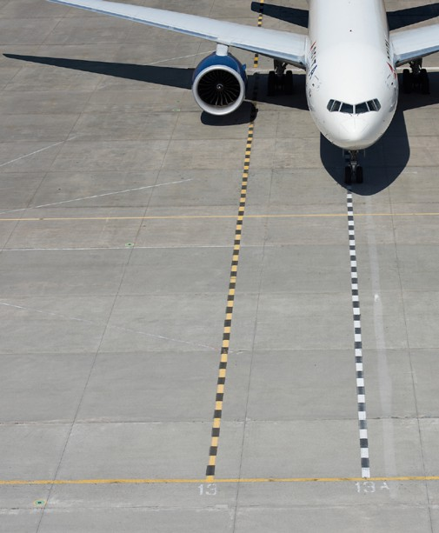
















Military Guard/
Reserve
Achieving “Mission Qualified” status 42 Months or less progress to DAl (Min 750-hr heavy or
fighter turbine time)
It is your career, so it should be your choice. Leveraging our partnerships, Delta is the only airline offering students a customized career path to Delta. Students may choose from three career routes:

- Flying for one of the Delta Connection Carriers
- A job-share instructing for your University and flying corporate aircraft for Delta Private Jets
- Flying military aircraft for the Air National Guard or Reserve

Program Commitments

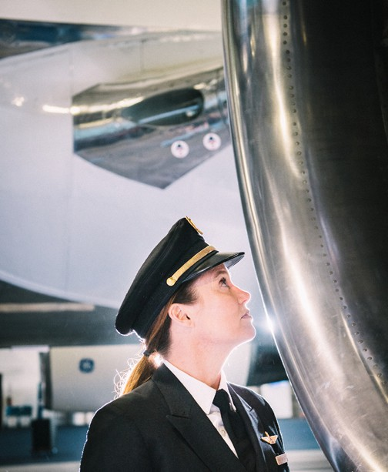
Commitment
There are many ways to become a pilot for Delta Air Lines. In order to successfully complete the Delta Propel program, pilots are expected to do the following:

- earn their Certificated Flight instructor Certificate
- Flight instruct for their University Flight school
- Flight instruct until the end of the semester in which they reach their R-ATP hours
- Fly in one of the three career routes: Delta Connection, Delta Private Jets, Air National Guard or Reserve
- Take the first available Captain upgrade

Who is eligible to participate?

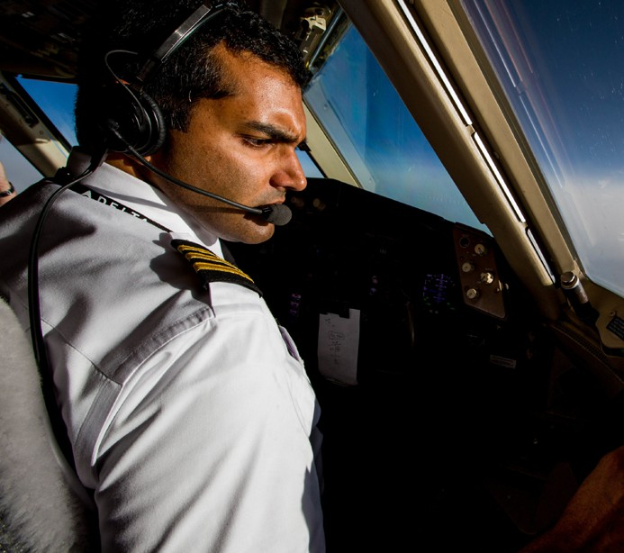





Juniors, Seniors and recently graduated Flight Instructors (within the previous six months) from partner institutions are eligible to apply for a Qualified Job offer as a Delta pilot. Students must possess at least a Private Pilot Certificate and have completed one additional Part 141 flight course at their current University.
Students are required to be enrolled in a major, or a recent graduate of a major, which allows the pilot R-ATP eligibility. In order to join the program, students must complete an interview and computer testing. By participating in Propel, students will complete all the qualification and testing requirements of the current Delta pilot selection model. Full program eligibility details and completion requirements can be found at propel.delta.com

What is a Qualified Job Offer?
- A Qualified Job offer offers you a defined path and accelerated timeline to become a Delta pilot – and then helps you achieve the necessary qualifications along the way.
- Pilots meeting the requirements of the Delta Propel program can progress through your chosen career route to Delta in 42 months or less - faster and more seamlessly than ever before.
- A career as a Delta Air lines pilot is extremely valuable; in addition to travel benefits around the world for Delta pilots and their family, health and disability insurances, and more.
- Meet the program requirements and expectations outlined in the Pledge

Climb higher






A Bright Future

Let us fly with you

The best benefit of Delta Propel, aside from having your choice of career paths to Delta, is the fact that Delta will be engaged with you throughout your entire journey. Signature events on-campus and at Delta’s World Headquarters strengthen your knowledge of the airline industry and develop your leadership skills. And to top it off, you will receive personal mentoring from an active Delta pilot every step of the way. For more information go to propel.delta.com



Application Process

Want to know all the details? Go the College path
page for the full list of requirements, schedule and links to apply.

What if I am not accepted into the program?
The Delta Propel - Collegiate Pilot Career Path is just one of many ways to become a Delta pilot. Delta Propel is meant to streamline your career and support you along the way. If you decide not to join or are not accepted into the program, you will still be eligible to apply to Delta in future semesters or later in your career. And we hope you do!

our current partner universities: Click college to find out more.

Apply To Fly

#deltapropel




Auburn university | Minnesota State university
Embry-Riddle Aeronautical university - Daytona | Middle Tennessee State university
Embry-Riddle Aeronautical university - Prescott | University of North Dakota
Middle Georgia State University | Western Michigan University

