

Faculty Handbook 2026–2027

School of Aviation

Department of Aviation Science & Management

Department of Aviation Maintenance & Structural Technology

Table of Contents

Table of Contents 2
1. Introduction 4
Message from the Dean 4
2. About the School 5
Vision 5
Mission 5
Unit Goals 5
Program Accreditation 5
3. Administrative Policies and Procedures 7
Absences and Sick Leave 7
Guidelines for Office Hours 7
Travel 7
Professional Conduct 7
Political Activity and Social Media 7
4. Instructional Policies 8
Classroom and Laboratory Expectations 8
Instructional Expectations and Procedures 8
Online Course Expectations 8
Attendance and Participation 8
Student Attendance Records 8
Student Expectations 8
5. Faculty Employment Policies 8
Part-Time Faculty 8
Full-Time Faculty 9
Qualifications and Credentialing 9
Retirement and Resignation 9
6. Faculty Rights and Responsibilities 9
Workload Policy 9
Advising 9
Scholarship 9
Service 9
Professional Development 9
7. Faculty Performance 10
Annual Evaluation 10
Promotion 10
Tenure 10
Post-Tenure Review 10
8. School and Department Committees 10
9. Other Policies and Procedures 10
Student Organizations 10
Communication 11
Outside Activities 11
Email Signatures 11
Directory Profile 11
Required Pre-Authorization Actions 11
Attendance at Graduation Ceremonies 11
Reserving Conference Rooms and Academic Space 11
Employee Mental Health Services 11
Student Mental Health Services 11

1. Introduction

Message from the Dean
This Faculty Handbook was created for the School of Aviation. The information contained within this document does not supersede policy found in the USG Policy Manual, USG Academic and Student Affairs Handbook, MGA Policies, or the MGA Faculty Handbook. The guidelines contained herein are intended to help faculty members better understand the culture and expectations within the School of Aviation and to provide guidance regarding teaching, scholarship, and service expectations.
The handbook has been prepared for the convenience of faculty and provides a general overview of School expectations and procedures. Faculty members are expected to be familiar with the information contained in the following documents available on the MGA website:
- BOR–USG Policy Manual
- USG Academic and Student Affairs Handbook
- Middle Georgia State University Faculty Handbook
- Middle Georgia State University Policy Manual (Human Resources)
- Middle Georgia State University Academic Catalog – Undergraduate
- Middle Georgia State University Academic Catalog – Graduate
- Middle Georgia State University Student Handbook and Code of Conduct
- Middle Georgia State University Student Policies
- Middle Georgia State University FERPA Guidelines
Kind Regards,
Adon Clark Dean, School of Aviation

2. About the School

Vision
Expand aviation training opportunities throughout the State of Georgia to allow for greater accessibility.

Mission
The School of Aviation educates and prepares students for technical and management careers in aviation, aerospace, and related industries. Graduates are expected to understand the industry and organizations of which they are a part and the communities they serve.

Unit Goals
The School of Aviation and its programs will:
- Offer benchmarked curricula that support workforce needs while meeting certification and accreditation standards.
- Attract and retain academically qualified students into affordable, accessible, and challenging degree programs.
- Develop relationships with alumni, practitioners, and industry partners to enhance program development.
- Collaborate with the profession, college, and community in service and research.
- Effectively manage institutional resources.
- Operate strategically in alignment with the mission and initiatives of Middle Georgia State University and the University System of Georgia.

Program Accreditation
The Bachelor of Science in Aviation Science and Management – Flight track is accredited by Aviation Accreditation Board International. This accreditation must be reaffirmed every five years.

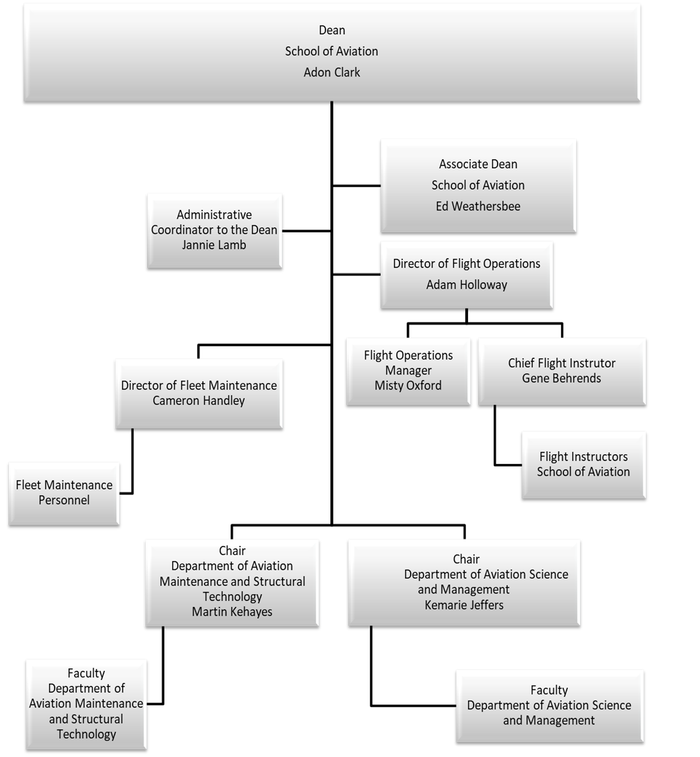

3. Administrative Policies and Procedures

Absences and Sick Leave
Faculty members are expected to meet punctually all regularly scheduled class sessions. Faculty members who must miss a class shall arrange with their School Dean or Department Chair to have the class covered. Faculty must notify their immediate supervisor in advance whenever possible.
If faculty are unable to attend office hours or class due to illness, appointments, or personal matters, the Department Chair and Administrative Assistant must be informed immediately. Such leave must be reported as sick time on the monthly time report in accordance with MGA policy and BOR policy regarding sick leave accrual and usage.

Guidelines for Office Hours
Office hours shall be filed within the faculty member’s academic unit. Faculty teaching a twelve-hour course load shall hold a minimum of eight on-campus office hours per week. Faculty teaching different course loads shall hold a proportionate number of office hours.
Office hours are defined as timeframes during university business hours when faculty are available to provide academic guidance, mentoring, or consultation to students.
Faculty should avoid scheduling appointments during posted office hours. Office hours must be posted outside the faculty member’s office and included in course syllabi.
If a faculty member must be absent during scheduled office hours, a notice must be posted and the Administrative Assistant informed.

Travel
All travel, including intercampus travel and conference travel, must be approved by the Department Chair and Dean. Travel guidelines and forms are available through the MGA Finance Office.

Professional Conduct
Faculty members are expected to adhere to BOR Policy 8.2.18 Personnel Conduct and the USG Statement of Core Values: Integrity, Excellence, Accountability, and Respect.

Political Activity and Social Media
USG employees are encouraged to fulfill civic responsibilities while ensuring political activities do not interfere with institutional duties. Employees must not represent themselves as speaking on behalf of the USG or the institution when engaging in political activity unless authorized.
State property, resources, and work time may not be used for political campaigning or expression.
Faculty should exercise professional judgment in social media interactions and remain mindful of professional responsibilities and institutional expectations.

4. Instructional Policies

Classroom and Laboratory Expectations
Faculty engaged in laboratory or instructional activities must communicate information related to supply shortages, safety concerns, hazards, or security issues to appropriate administrative personnel.
Laboratory requirements and expectations are coordinated through the Department Chair or Assistant Department Chair.

Instructional Expectations and Procedures
Course syllabi must follow the official MGA syllabus template and be submitted electronically to the School prior to the start of the semester. Syllabi must be posted in D2L prior to the first day of class.
All communication between instructors and students must occur through MGA email or D2L communication tools.
Faculty are expected to respond to student communications within 24 hours during the work week when feasible. Feedback and grades should normally be returned within one week of submission.

Online Course Expectations
Online courses are asynchronous unless otherwise approved. D2L is the official platform for course delivery, assessments, gradebook management, and communication.
External tools may be used only with approval and must not contain student personal data.
Online courses must utilize approved School of Aviation templates. Sections of the same course may not be combined into a single course shell.

Attendance and Participation
Attendance in online courses is defined as active participation through assignments, discussions, or assessments as outlined in the course syllabus.

Student Attendance Records
Faculty are required to maintain accurate attendance records for all courses. Records must be retained for a minimum of three years. For unsuccessful grades, the last date of attendance must be recorded.

Student Expectations
Students should refer to the MGA Student Handbook for policies regarding conduct, attendance, and grade appeals.

5. Faculty Employment Policies

Part-Time Faculty
Refer to USG Policy 4.2 for the definition of part-time employment.

Full-Time Faculty
Refer to USG Policy 8.2 for general personnel policies.

Qualifications and Credentialing
Faculty qualifications must meet minimum standards outlined in USG Policy 8.3.1.2 and MGA Faculty Handbook credentialing guidelines.

Retirement and Resignation
Refer to USG Policy 8.2.8.2 for definitions and eligibility requirements related to retirement.

6. Faculty Rights and Responsibilities

Workload Policy
Faculty responsibilities include teaching, advising, service, professional development, and scholarly activity. Teaching is the primary responsibility for faculty at MGA.
Workload distribution may vary based on assignment and qualifications, but typically includes teaching, service, and scholarship/professional development components totaling 100% of assigned duties.

Advising
Faculty are expected to participate in advising and mentoring activities to support student success and progression.

Scholarship
Scholarship expectations follow the Boyer model, including discovery, integration, application, and teaching. Scholarly activities may include publications, presentations, grant activity, curriculum development, and professional certification advancement.

Service
Service includes contributions to the department, school, university, profession, and community.

Professional Development
Faculty are encouraged to engage in activities that enhance professional knowledge and instructional effectiveness, including workshops, conferences, and continuing education.

7. Faculty Performance

Annual Evaluation
Faculty evaluation follows MGA Faculty Handbook guidelines and includes assessment of teaching effectiveness, student success involvement, scholarship or professional achievement, service, and professional growth.
Evaluation ratings include:
- Does Not Meet Expectations
- Needs Improvement
- Meets Expectations
- Exceeds Expectations
- Exemplary

Promotion
Refer to USG Policy 4.6 for promotion requirements.

Tenure
Refer to USG Policy 4.5 for tenure requirements.

Post-Tenure Review
Refer to USG Policy 4.7 for post-tenure review procedures.

8. School and Department Committees
Faculty are expected to participate in departmental and school committees as outlined in the MGA Faculty Handbook.
School committees include:
- Curriculum Committee
- Faculty Development Committee
- Textbook Approval Committee
- Alumni Affairs Committee
- Aviation Safety Committee
- Advisory Committee

9. Other Policies and Procedures

Student Organizations
Information regarding student organizations is available through the School of Aviation.

Communication
School news and updates are communicated through Inside MGA and official institutional channels.

Outside Activities
Faculty outside employment and consulting activities must comply with MGA policy and receive appropriate approval.

Email Signatures
Faculty email signatures must follow institutional formatting standards.

Directory Profile
Faculty are responsible for maintaining accurate directory information.

Required Pre-Authorization Actions
The following actions require prior authorization:
- Canceling class sessions
- Changing assigned classrooms
- Moving students between course sections
- Conference or work-related travel
- Outside occupational activities

Attendance at Graduation Ceremonies
Faculty are expected to attend graduation ceremonies as assigned.

Reserving Conference Rooms and Academic Space
Reservations must be coordinated through the Administrative Assistant.

Employee Mental Health Services
Employee assistance and counseling resources are available through USG programs and Human Resources. Services are confidential.

Student Mental Health Services
Faculty should refer students needing assistance to appropriate campus counseling or mental health support services.

This handbook will be modified as institutional needs and policies evolve.

