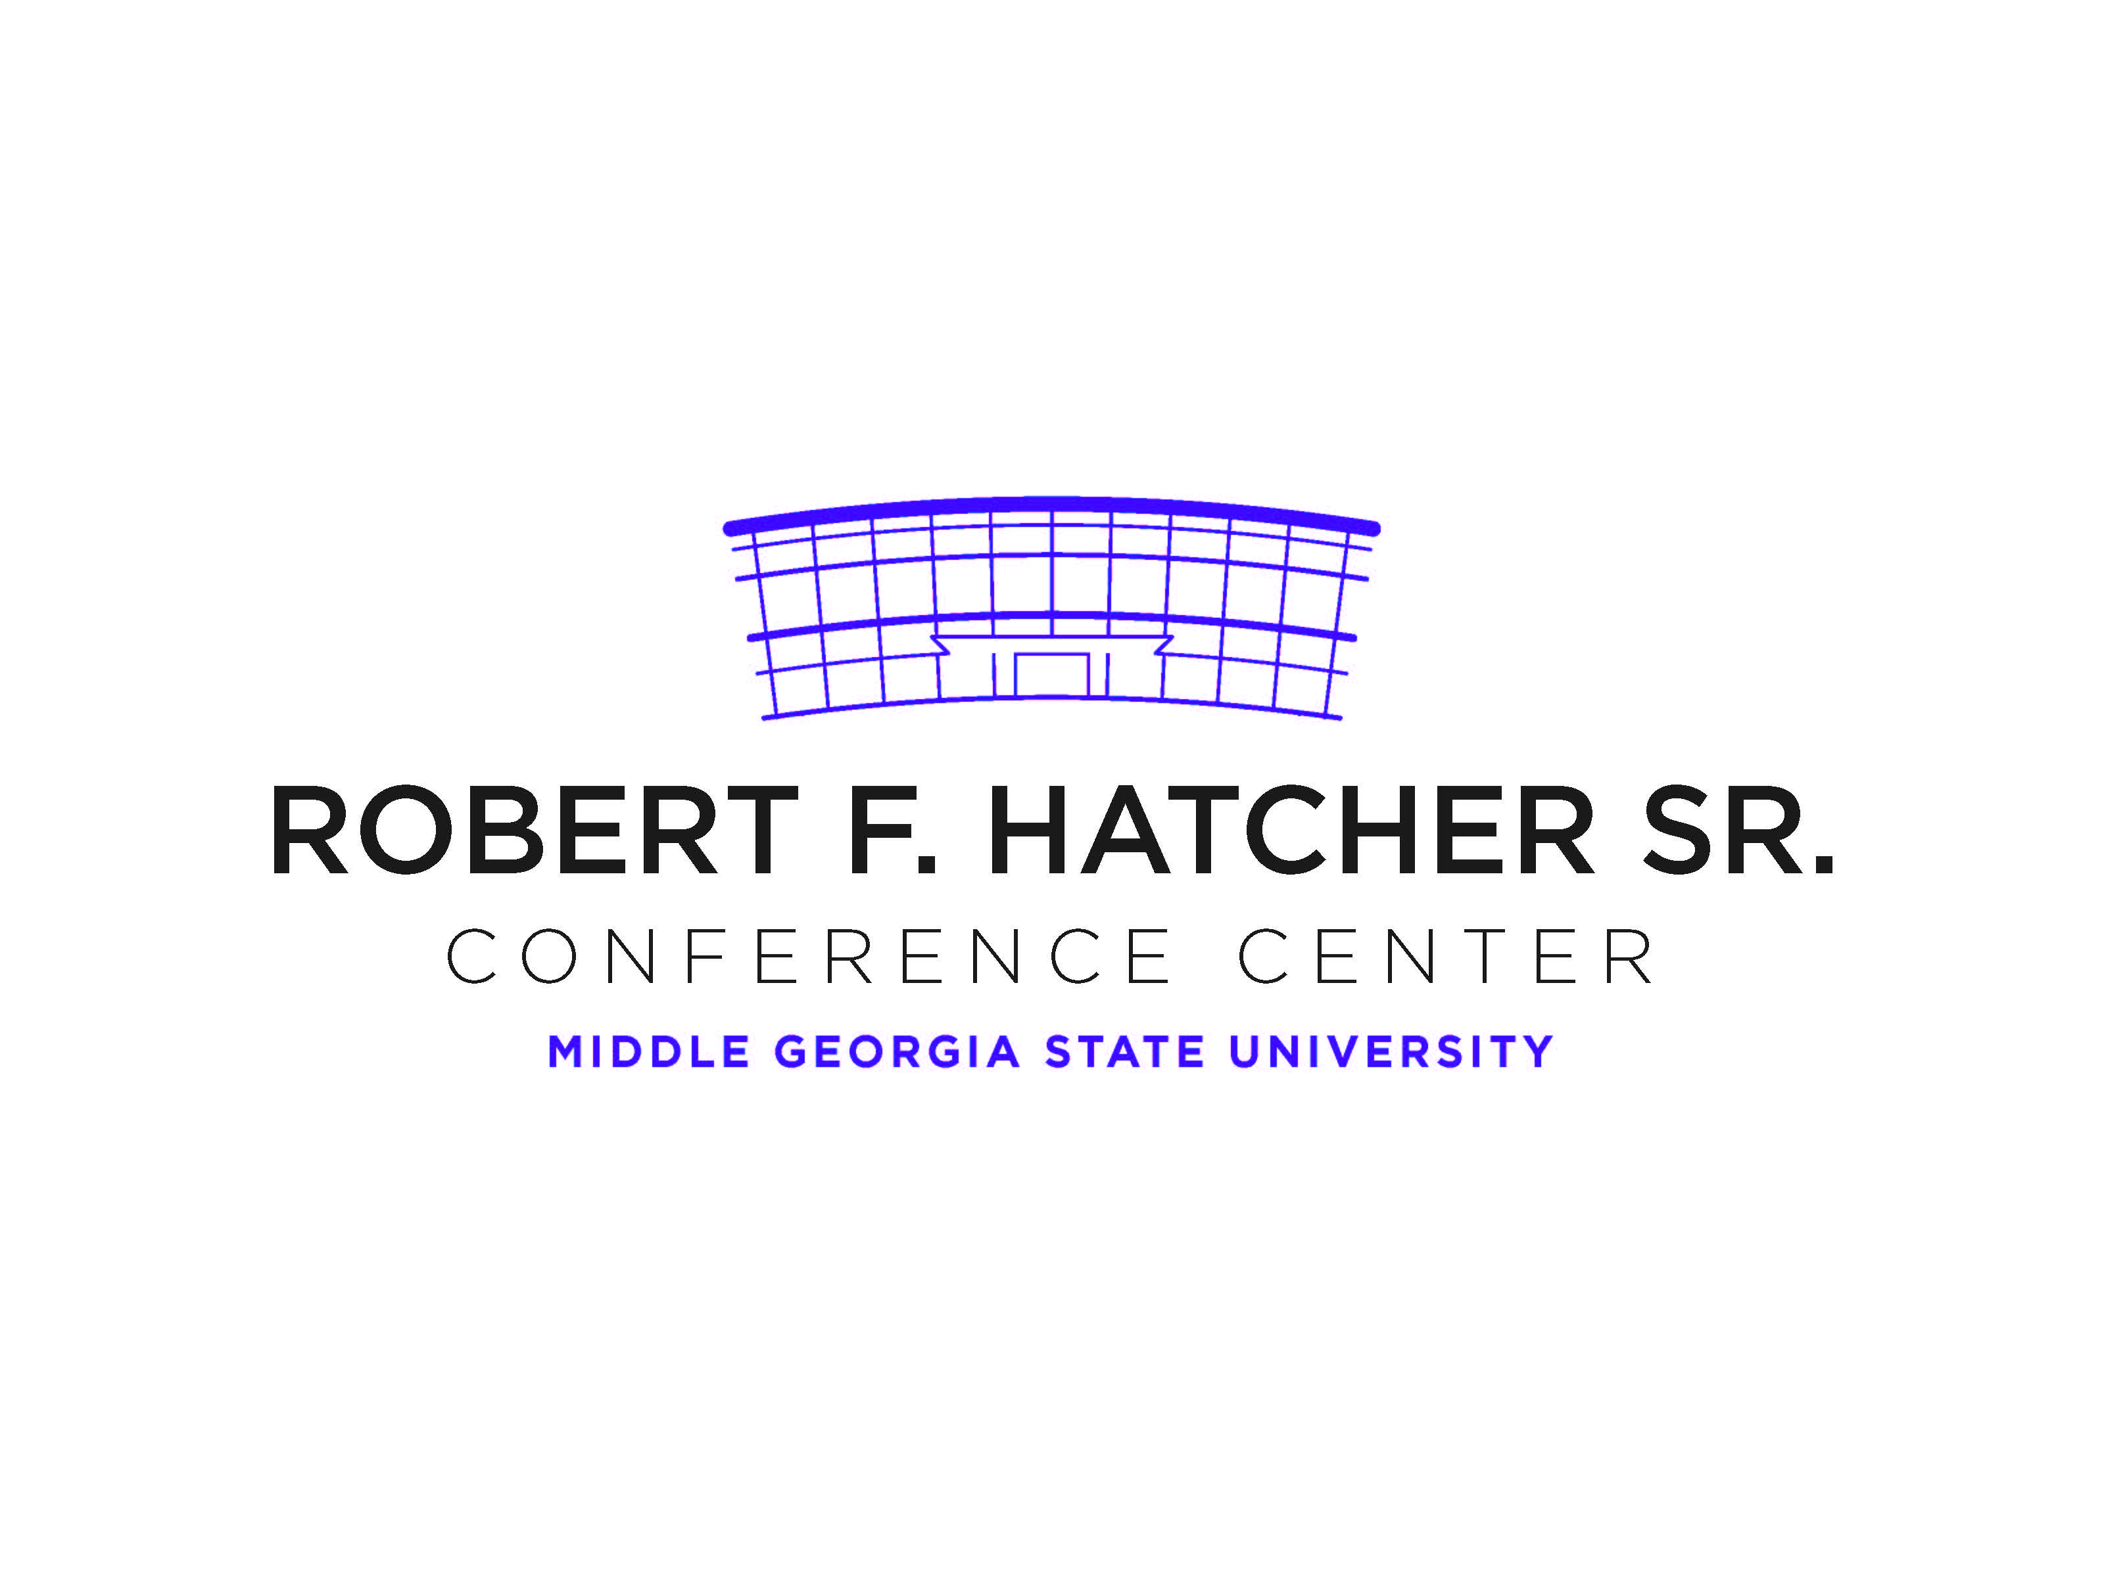

**TEMPORARY PARKING PERMIT**

***VALID DATE: April 21, 2022***

**IT Cybersecurity Conference**

DO NOT PARK IN FACULTY/STAFF PARKING AREAS.

DO NOT BACK INTO SPACE

DISPLAY PERMIT ON DASHBOARD OR REAR WINDOW

Smoking is prohibited on campus